10-20 MHz duplexer, 2 coil design with 2 0.6 uH inductors and C2 = 120 pF to ground at centre C1 = 0 (stray capacitance?)
(L = 0.8 mm wire, 9 turns tight wound on 10 mm drill bit)

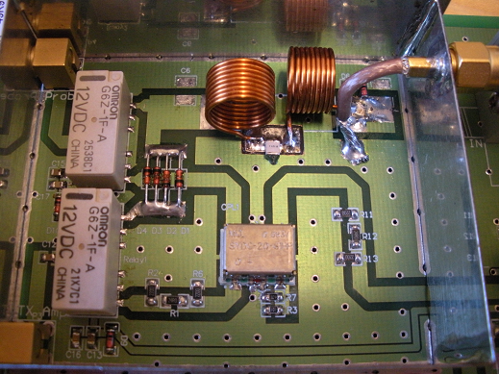

10-25 MHz duplexer, L1 = 0.67 uH (9t) , L2 = 0.42 uH (7t), C1 = 39 pF (reduced from 51 pF)
C2 = 100 pF
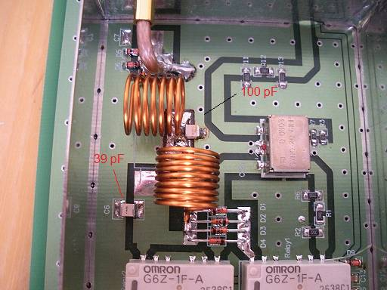

13-30 MHz duplexer, 2 coil design with L1 = and L2 = inductors and C1 = 22 pF to ground at centre C2 = 82 pF
(L = 0.8 mm wire, L1 8 and L2 7 turns wound over 11 mm on 10 mm drill bit)

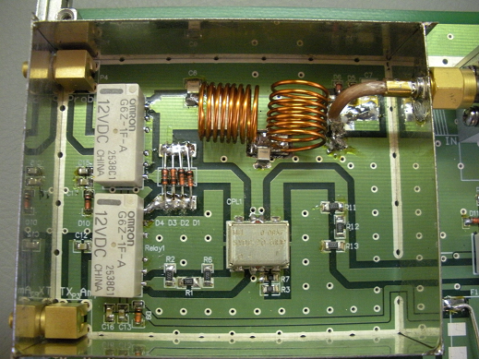

20-40 MHz duplexer, 2 coil design with two 0.27 uH inductors and C2 = 47 pF to ground at centre C1 = 0 (stray capacitance?)
(L = 0.8 mm wire, 6 turns wound over 9 mm on 10 mm drill bit)

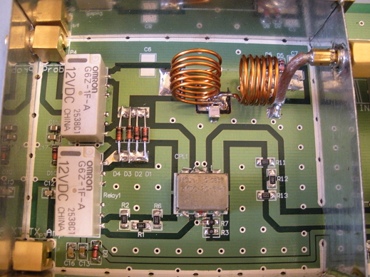

20-50 MHz duplexer, 2 coil design with two 0.27 uH inductors and C2 = 47 pF to ground at centre C1 = 0 (stray capactiance?)
(L = 0.8 mm wire, 6 turns wound over 9 mm on 10 mm drill bit)

